**CPU vs GPU in Machine Learning**

Any data scientist or machine learning enthusiast who has been trying to elicit performance of her learning models at scale will at some point hit a cap and start to experience various degrees of processing lag.

Tasks that take minutes with smaller training sets may now take more hours—in some cases weeks—when datasets get larger. You’ll need the best hardware, and while researching you will come across and may get confused with CPUs, GPUs, and ASICs.

A central processing unit (CPU) is essentially the brain of any computing device, carrying out the instructions of a program by performing control, logical, and input/output (I/O) operations.

A graphical processing unit (GPU), on the other hand, has smaller-sized but many more logical cores (arithmetic logic units or ALUs, control units and memory cache) whose basic design is to process a set of simpler and more identical computations in parallel.

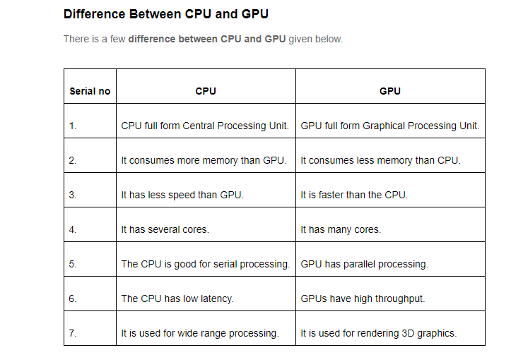

**Features of GPU and CPU:**

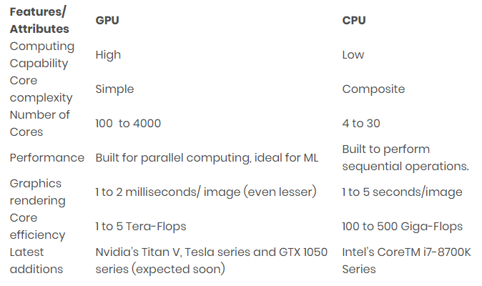

**Applications of CPU, GPU and TPU:**

